TELECOMMUNICATIONS
TRAINING MANUAL
SEARCH AND RESCUE ALBERTA
Aug. 08, 2009

Compiled by Sean Smith for the
SARAB Telecommunications Committee.
Revised and Modified by:
Rick Koinberg (VE6RAK), Jack Humpries (VA6IX)
Bill Heise (VE6SAS), Lyn Michaud (VE6OGN)
Approved unanimously as a Standard for Search and Rescue Alberta at the 2009 Annual Meeting
For Clarification and Questions
Rick Koinberg rick.koinberg@gmail.com 403-337-0181
Jack Humphries jack_humphries@shawbiz.ca 403-556-6775

Introduction
The purpose of this document is to provide a standard teaching method for radio communications training among the Search and Rescue Alberta member organizations. This will be achieved by the use of common phraseology, record keeping, and training.

This set of standards is based on International Telecommunications Union (ITU), Incident Command System (ICS), and Alberta Sustainable Resources standards along with Amateur Radio Emergency Service (ARES) procedures. These standards were chosen because of their simplicity and wide acceptance with in the province of Alberta.

Terminology
Base Radio | - A transceiver that is located at a fixed location during the incident.
Hand Held Radio | - A small transceiver that is battery powered and portable. Also known as Portable, Handy Talky or Walky Talky.
Mobile Radio | - A transceiver that is mounted in a vehicle
Station | - Any radio transceiver that is used in an incident.
Base | - The incident command post radio call sign.
Command | - The incident commander radio call sign.
Net Control or  Control | - The person that co-ordinates communications traffic, and maintains accurate records of the traffic.
Staging | -Under ICS this is " where resources are kept while awaiting assignment" This maybe at the Command Post area or it maybe at a secondary area or both. Maybe managed by a Staging Area Manager who reports to the Operations Section Chief or I/C if there is no Ops Chief.  -A specific name may be applied before the word staging if more then one is used. i.e. Bear Creek Staging
Alpha | -Prefix assigned to Medical Teams
Bravo | -Prefix assigned to specialized resources, not just boats - boats, ATVs, Bikes, Horses
Delta | -Prefix assigned to Dog Teams
Hotel | -Prefix assigned to Helicopter units or the aircrafts call sign maybe used i.e. C-GAHM
Sierra | -Prefix assigned to Search teams
Tango | -Prefix assigned to Tracking teams

Procedures

Note: Recommended that Net Controllers have a Scribe to assist in recording traffic.

Small response incidents 1 – 5 teams
During a small response incident a radio station located at the incident command post is required, and one radio per field team involved in the incident. The radio station at the command post must be manned at all times. If trained personnel are available, the Command Post radio shall be manned by a dedicated radio operator who will act as Net Control. The Incident commander or Search Manager may act as the Net Control if resources are limited. All communications traffic shall be logged on ICS form ICS-309.
The Incident Commander, and all field teams will be equipped with either a two-way radio or other means of communication that allows direct communication with the Net Control Operator.

Medium response incidents 6 – 15 teams
In a medium response incident there shall be a dedicated radio operator or operators who perform the function of Net control in the command post at all times. All communication traffic handled by the Net Control Operator(s), including but not limited to radio, telephone, and faxes are to be recorded on ICS form ICS-309.
The Incident Commander, and all field teams will be equipped with either a two-way radio or other means of communication that allows direct communication with the Net Control Operator.

Large response incidents greater then 15 teams
During large response incidents, where multiple agencies are involved, it may be necessary to have several net control operators for different frequencies in the command posts at all times. Co-ordination between these net control operators if they are not at the same location will be done on one of the following frequencies.
Mutual Aid Rx 156.8550 MHz Tx 156.8550 MHz * Provincial Mutual Aid Frequency
SAR-IF 149.080 Mhz Simplex
SAR Rx 417.9625 MHz Tx 412.9625 MHz *Assigned for SAR use in AB, SK, MB
SAR Rx 417.5500 MHz Tx 412.5500 MHz *Assigned for SAR use in AB, SK, MB
SAR frequencies may be used during any incident.
NOTE: The Mutual Aid frequency is only to be used during multi agency incidents
The Incident Commander, and all field teams will be equipped with either a two-way radio or other means of communication that allows direct communication with the Net Control Operator.

FREQUENCIES USED ON SEARCH MISSIONS
RCMP Tac 8 Rx 156.030 MHz Tx 156.030 MHz
RCMP Tac 9 Rx 155.670 MHz Tx 155.670 MHz
SAR-IF 149.080 Mhz Simplex see http://www.nss.gc.ca/site/SAR_IF/index_e.asp
And http://www.nss.gc.ca/site/SAR_IF/SARIF_Terms_and_conditions.pdf

NOTE: You must have permission letters from each licensee to use their frequency, the transceiver must be licensed, and you must provide Industry Canada with copies of the letters of permission.

Training
‘Search and Rescue teams with in the province of Alberta draw from such a wide range of backgrounds in radio communications from the complete novice to the communications professional. This wide range makes it necessary to have standardized training with in the province to ensure that teams are able to communicate effectively, and efficiently.

Three levels of training are required, Field Team Communicator, Net Control Operator, and Communications Technician.

- Field Team Communicator
This level is the most basic level of training. It teaches the SAR worker in the field to effectively use their radio during an incident. Any Search and Rescue Fundamentals Instructor, Industry Canada Approved Examiner, or Licensed Amateur Radio operator may teach this level providing that they follow the training syllabus below.

The training shall include but not limited to the following areas:

- Basic radio theory
-Propagation
-Anatomy of radios
-Types of radios
-Hand Held
-Mobile
-Mobile Antennas
-Base
-Connectors
-Repeater

- Use of radios
- Battery Replacement
- Using the controls
- Posture of the user

- Communication Protocols
- ITU Alphabet
- Use of plain language
One exception 40 Code: 1062 means turn radio off or move away from group. - Calling procedures

- Hands On use of radios
- Calling other stations
- Passing traffic

Net Control Operator

The purpose of a Net Control Operator is to co-ordinate communications traffic, and to maintain accurate records of the traffic. This person is the key to maintaining effective communications. Any Search and Rescue Fundamentals Instructor, Industry Canada Approved Examiner, or Licensed Amateur Radio operator may teach this level providing that they follow the training syllabus below.

The training shall include but not limited to the following areas:
- Base Radio setup and use
- Communications Traffic Logging
- Multiple Radio use simulation

- Communications Unit Leader
Communications Unit Leader are the personnel who maintain the communications equipment and setup advanced equipment such as repeaters, radio links, and phone patches. These will usually be people who do such things for a living or experienced Amateur Radio Operators. Individuals seeking this level shall be evaluated by not less than three of their peers comprising of Communications Unit Leaders or members of the Search and Rescue Alberta Telecommunications Committee.

Record Keeping

Communications Traffic

All communication traffic will be logged by the Net Control Radio Operator on ICS form ICS-309 included in Appendix C.

Training Records

Records of training for personnel shall be kept on file by the member’s organization and made available upon request of Search and Rescue Alberta or the tasking agency.

Appendix A -International Telecommunications Union Alphabet

Capital letters indicate which syllable to stress.
A | Alpha | (AL fah)
B | Bravo | (BRAH voh)
C | Charlie | (CHAR lee *or* SHAR lee)
D | Delta | (DELL tah)
E | Echo | (ECK oh)
F | Foxtrot | (FOKS trot)
G | Golf | (GOLF)
H | Hotel | (hoh TELL)
I | India | (IN dee ah)
J | Juliett | (JEW lee ETT) (NOTE SPELLING: 2 T's)
K | Kilo | (KEY loh)
L | Lima | (LEE mah)
M | Mike | (MIKE)
N | November | (no VEM ber)
O | Oscar | (OSS car)
P | Papa | (pah PAH) (NOTE STRESS IS ON THE 2ND SYLLABLE)
Q | Quebec | (keh BECK)
R | Romeo | (ROW me oh)
S | Sierra | (see AIR rah)
T | Tango | (TANG go)
U | Uniform | (YOU nee form)
V | Victor | (VIK tor)
W | Whiskey | (WISS key)
X | X-ray | (ECKS ray)
Y | Yankee | (YANG kee)
Z | Zulu | (ZOO loo)

The information in this post quoted from The American Radio Relay League Operating Manual
(1990 edition), published by the American Radio Relay League, Newington CT USA, 06111.

APPENDIX B Communications Log ICS-309

COMMUNICATIONS LOG | TASK # |  | DATE PREPARED:  TIME PREPARED:
FOR OPERATIONAL PERIOD # | TASK NAME:
RADIO OPERATOR NAME (LOGISTICS): |  | STATION I.D.
LOG

 | STATION I.D.
TIME | FROM | TO | SUBJECT
PAGE __ OF __ |  |  |  | ICS 309
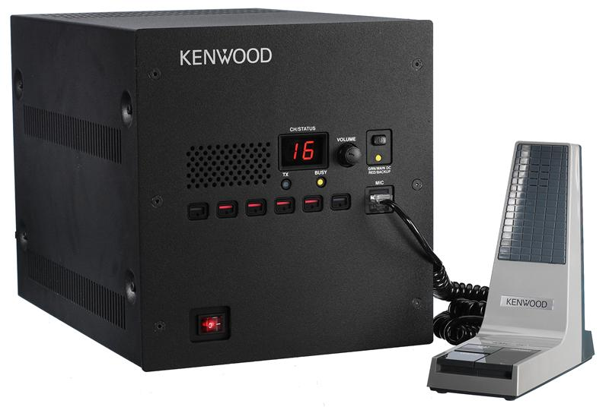
Base Unit

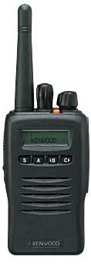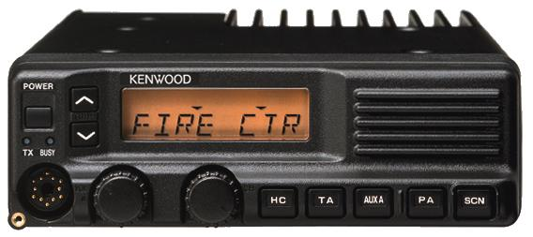
Hand Held
Mobil

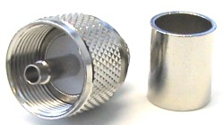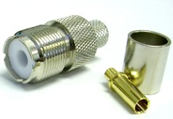

PL 259 or uhf male connector uhf female connector

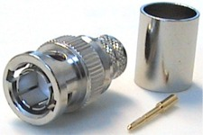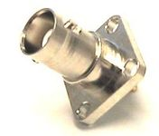
bnc male connector bnc female connector

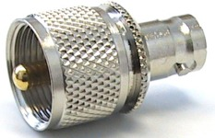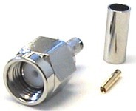
uhf male to bnc female adaptor sma male connector

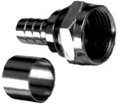
F male connector for TV

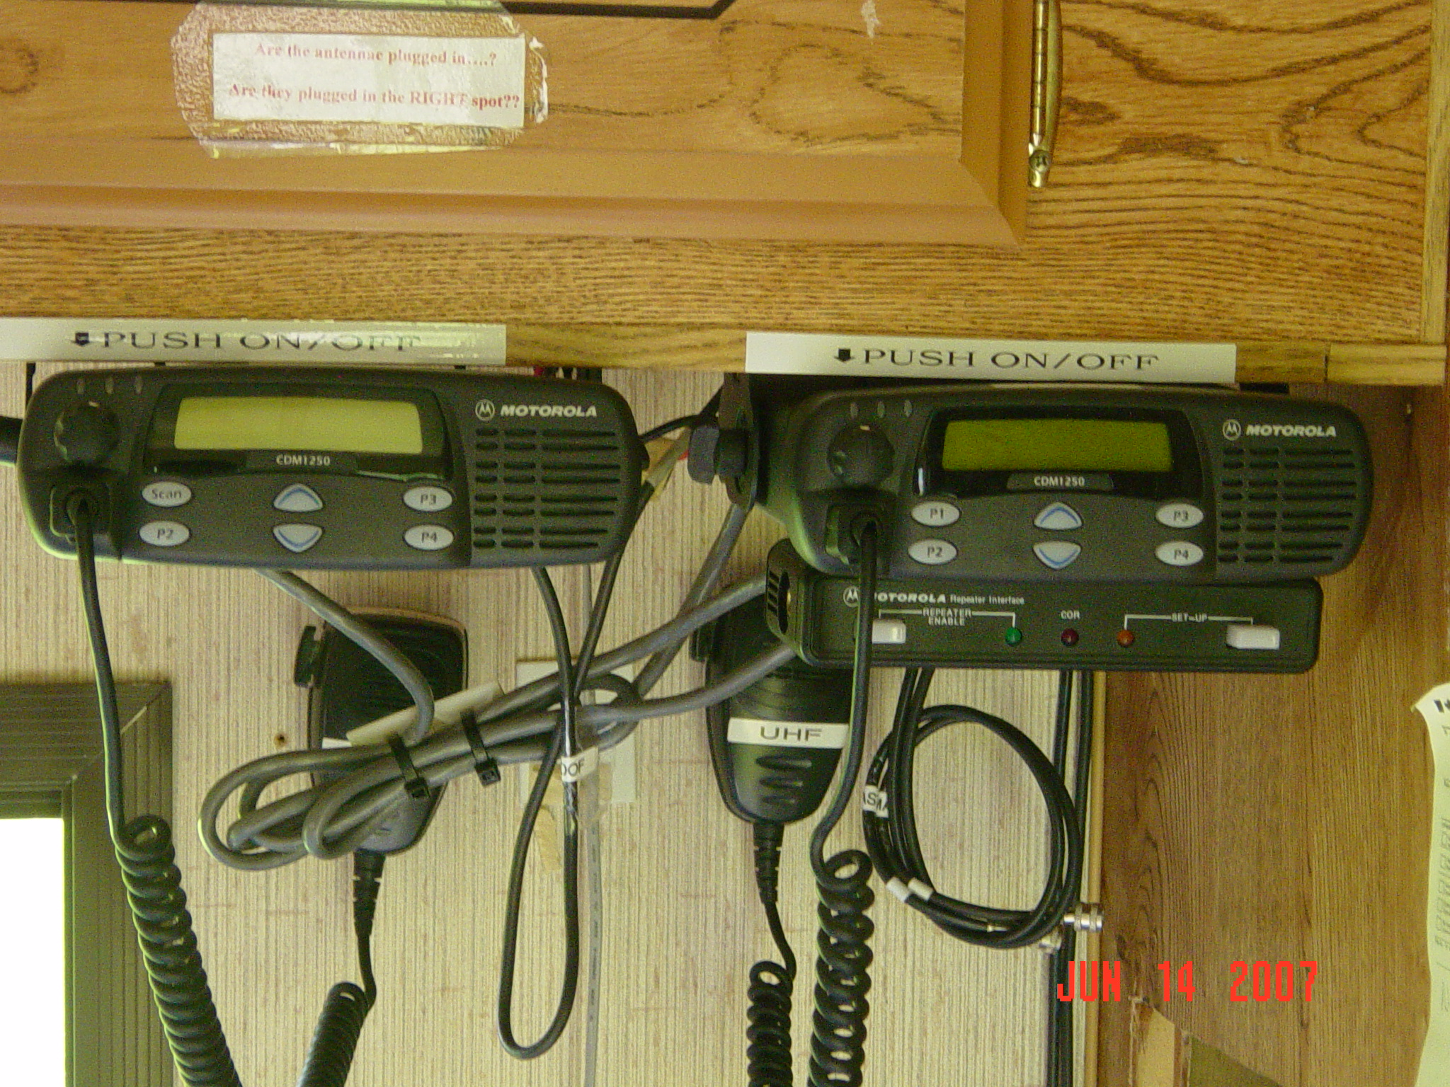

VHF and UHF radio installation

